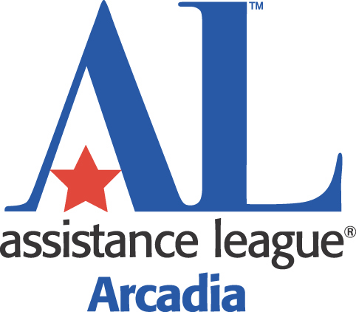
Links to Learning Awards 2017
Application Instructions and Guidelines

Links to Learning provides an opportunity for teachers and non-administrative staff to apply for monetary awards to enhance and expand curriculum to enrich students’ education and classroom experiences. The intended goal of the awards is to serve the greatest number of students and to encourage the use of non-consumable items that will benefit future learners with hands-on learning or the use of technology for research and application. Links to Learning 2016 awarded over $10,000 to teachers and staff of Temple City and Rosemead School Districts.

Instructions/Guidelines:

- Any teachers and non-administrative school staff of San Gabriel Unified School District may apply.
- Detailed descriptions and cost itemization are highly recommended. Typed application is preferred.
- Scan and email completed application form to linkstolearning.ala@gmail.com (use additional sheets if needed). Applications may not exceed a total of 3 pages and should be submitted as one document.
- All parts of the application must be completed, including the applicant and principal’s required signatures.
- Maximum award request is $500 per teacher/application. Teachers/Staff can apply together for a total of $500 X number of teachers/staff on application. Do not submit duplicate applications; instead, put all names together on one application.
- Each individual may submit more than one application.
- Deadline for application submission is Monday, March 20, 2017. Applications received after the deadline will not be considered.
- Notifications will be emailed to awardees by April 3, 2017.
- Awardees will be sent instructions how to submit authorized material receipts for reimbursement.
- Deadline for submitting receipts for reimbursement is Monday, May 1, 2017. Reimbursement will be processed within 15 days.
- Awardees will be invited to an Awards Presentation.
- Assistance League of Arcadia reserves the right to publicize all awards granted.

Good Luck!

Charlene Martinez
Assistance League of Arcadia
Links to Learning Committee Chairman

Links to Learning Award Application
for San Gabriel Unified School District
Deadline March 20, 2017
(Please type or print.)

Applicant’s Name/Names: Proposed Project Title:

Email Address: Requested Grant Amount:

Grade Level/Subject: Estimated # of Children Served:

School Name: Estimated # of Years of Possible Use:

Proposal: (Attach up to 2 additional sheets if needed)

Itemize equipment and material for which you request funding. Indicate budget price for each item, including tax and shipping:

I AUTHORIZE Assistance League of Arcadia to publish information about my Links to Learning Award Application on their website and publicity materials.

Applicant’s Signature: ______________________________________ Date: ____________

I APPROVE the Links to Learning Application for the above materials.
Principal’s Signature: ______________________________________ Date: _____________
Scan and email the completed application as one document to linkstolearning.ala@gmail.com
by March 20, 2017 for consideration.

