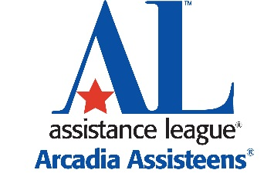
2017-18 Assisteens® Application
Auxiliary of Assistance League® of Arcadia
Please print clearly. Application Deadline is March 1, 2017.

Legal Name ________________________________________ Nick Name _______________________

Cell Phone ______________________________ Home Phone _______________________________

Address____________________________________________________________________________

School Now Attending _____________________ School Attending Fall 2017 ______________________

Grade Level Fall 2016 _________ Email Address ___________________________________________

Name and relationship to Assistance League or Assisteens member if any________________________

You may attach additional pages if needed for the following answers:
List your extracurricular and volunteer activities including school and community involvement.
Organization or Group Positions Held Dates Involved

___________________________________________________________________________________

__________________________________________________________________________________

Total hours per month currently required of you for above activities___________

What do you hope to gain or learn by joining Assisteens? _____________________________________

___________________________________________________________________________________

Why is community service important to you? _______________________________________________

___________________________________________________________________________________

What do you do that you are passionate about? ____________________________________________
I agree to attend monthly meetings and commit to support all of Assisteens philanthropies and activities. (32 total hours per year as a new member in addition to meetings.)

Applicant Signature_______________________________________________ Date_______________
I am aware that membership in Assisteens commits my child to monthly meetings and volunteer service. I am willing to contribute 8 to10 hours of service to assist with Assisteens activities. I am supportive of my child’s decision to apply and will help my child to meet their responsibilities as a member of Assisteens.
Parent/Guardian Signature _________________________________________ Date_______________

Parent Email___________________________________________

Please scan and email completed application to assisteens.arcadia@gmail.com
OR Mail completed form to Sandi Consiglio, Assisteens Coordinator
c/o Assistance League of Arcadia
100 S. Santa Anita Ave.
Arcadia, CA 91006

